Swansea

1. Bot entered an sample address in search field

Address - Uplands Nursing Home Ffynone Road,Swansea

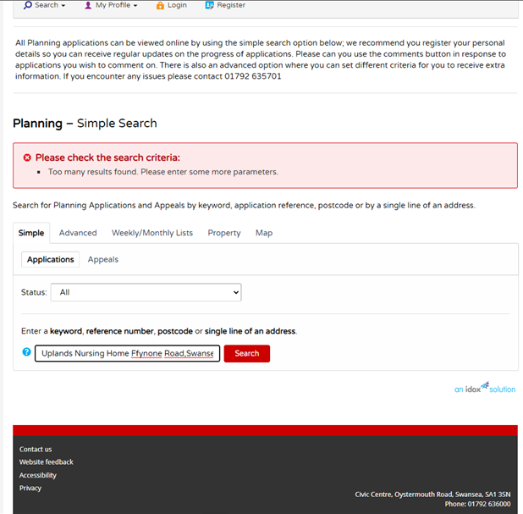

1. Multiple results related to that address are shown

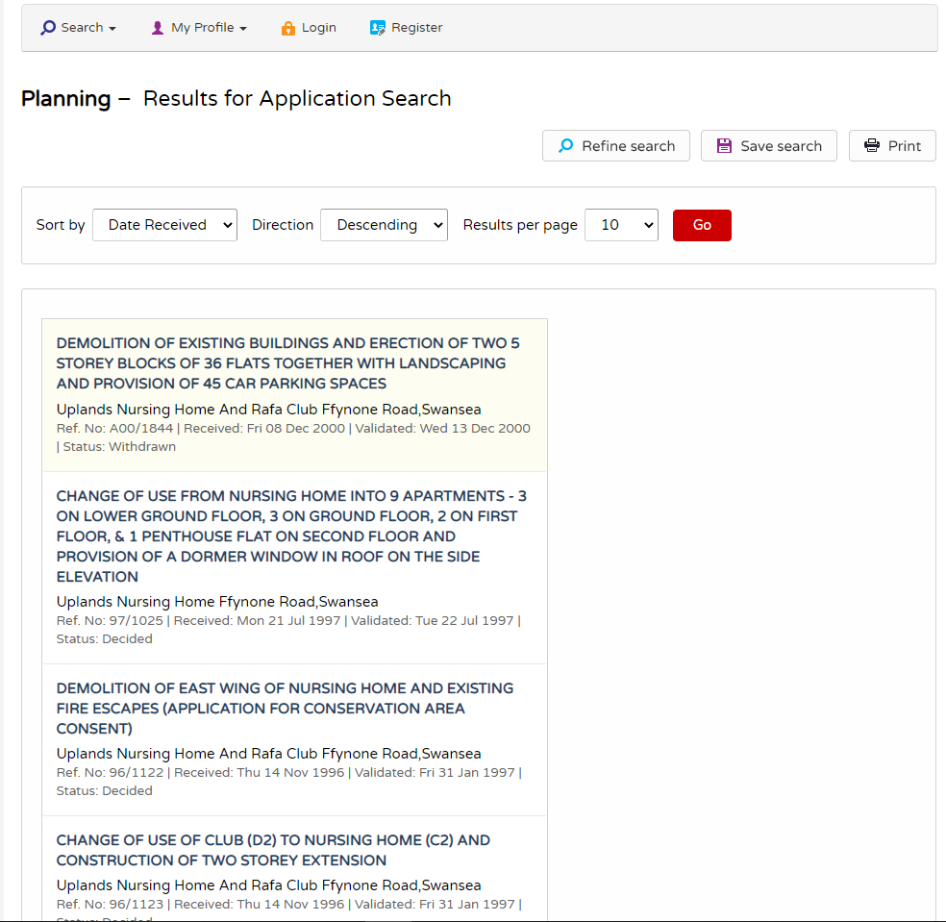

1. So bot has extracted the Important dates & summary tabs fields for all shown results

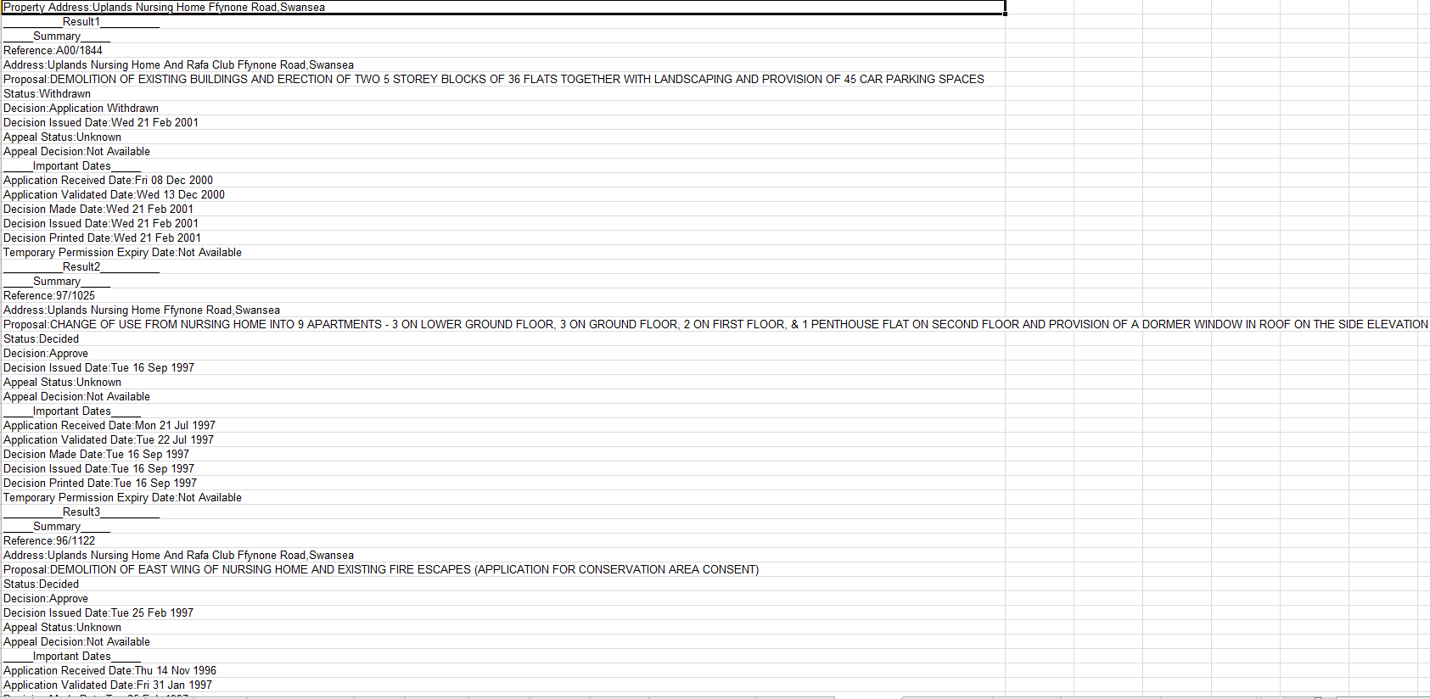

## Questions:

1. Does multiple results always shown for an address that we enter in Swansea website
2. Do we need to extract Summary & Important dates field for every results that shown for an address

Responses:

1. Multiple responses could show for all properties with any Local Authority.
2. Essential data to be extracted as follows:

Reference

Address

Proposal

Status

Decision

Decision Issued Date

Spacing on response sheet could be better.